IELTS Academic Writing Task 2 Activity – Student’s Worksheet 1

  - Is the text in normal print simply advice, or do candidates have to follow it?
  - Are there two sentences that give candidates instructions here?
  - Is the writing in bold italics the question candidates have to answer?
  - Do candidates only have to answer the question ‘To what extent do you agree or disagree ’?
  - Is it enough for candidates to just give their own opinion about this topic?
  - Do candidates have to pretend to be a specialist when they are writing their answer?

IELTS Academic Writing Task 2 Activity – Student’s Worksheet 2

Advantages of Nuclear Power | Advantages of Nuclear Weapons
Disadvantages of Nuclear Power | Disadvantages of Nuclear Weapons

IELTS Academic Writing Task 2 Activity – Student’s Worksheet 3

Which of these ideas could be included in this essay?

The development of weapons through history
Suggestions for achieving world peace
Our increasing reliance on modern technology
The depletion of natural resources
The high cost of fuel

IELTS Academic Writing Task 2 Activity – Student’s Worksheet 4

Introduction | Cause and effect | Conclusion
Today… | As a result… | In conclusion…
And | But | For example
Also… | However… | Such as…

IELTS Academic Writing Task 2 Activity – Student’s Worksheet 5

Look at Sample scripts A and B and answer the following questions:

 |  | Sample Script A | Sample Script B
THE INTRODUCTION
1. | Does the introduction tell you exactly what the topic is?
2. | Do any of the ideas need more information?
3. | What connectors have been used to improve the cohesion of the paragraph?
THE BODY OF THE ESSAY
1. | What benefits of nuclear technology does the writer give?
2. | Are the benefits given different to the ones in the title?
3. | What disadvantages of nuclear technology does the writer discuss?
4. | What connectors are used to link the ideas together?
5. | Is there enough evidence to support the writer’s claims and ideas?
6. | Do any of the ideas need to be developed further?
7. | Are any ideas repeated too often?
THE CONCLUSION
1. | Is it clear where the conclusion begins?
2. | Does the conclusion summarise the ideas used in the body of the essay?
3. | Is the question ‘Do you agree or disagree?’ answered?
4. | What connectors are used in the conclusion?

IELTS Academic Writing Task 2 Activity – Sample Task

Sample task

Academic Writing Sample Task 2B

You should spend about 40 minutes on this task.

Write about the following topic.

The threat of nuclear weapons maintains world peace. Nuclear power provides cheap and clean energy.

The benefits of nuclear technology far outweigh the disadvantages.

To what extent do you agree or disagree?

Give reasons for your answer and include any relevant examples from your knowledge or experience.

Write at least 250 words.

IELTS Academic Writing Task 2 Activity – Sample Script A

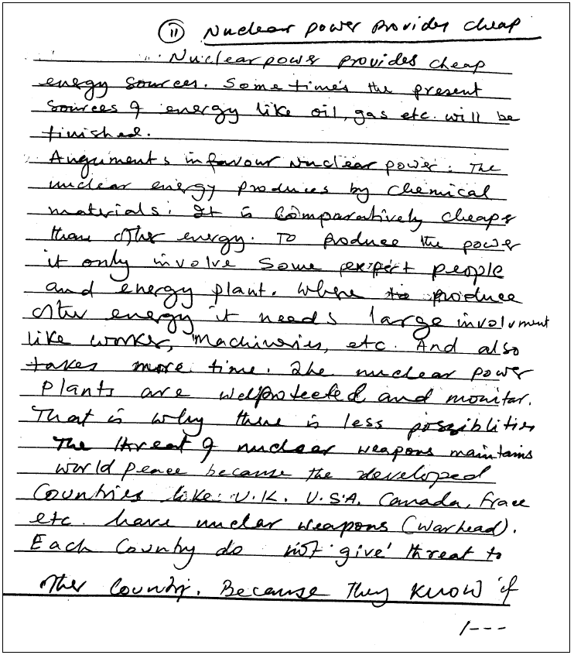

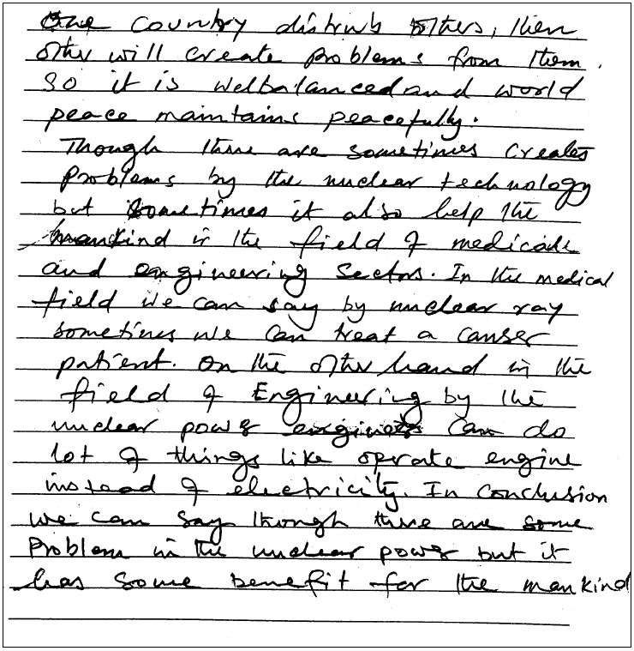

Examiner comment

Band 5
Although the script contains some good arguments, these are presented using poor structures and the answer is not very coherent. The candidate has a clear point of view but not all the supporting arguments are linked together well and sometimes ideas are left unfinished. There is quite a lot of relevant vocabulary but this is not used skilfully and sentences often have words missing or lapse into different styles. The answer is spoilt by grammatical errors and poor expression.

IELTS Academic Writing Task 2 Activity – Sample Script B

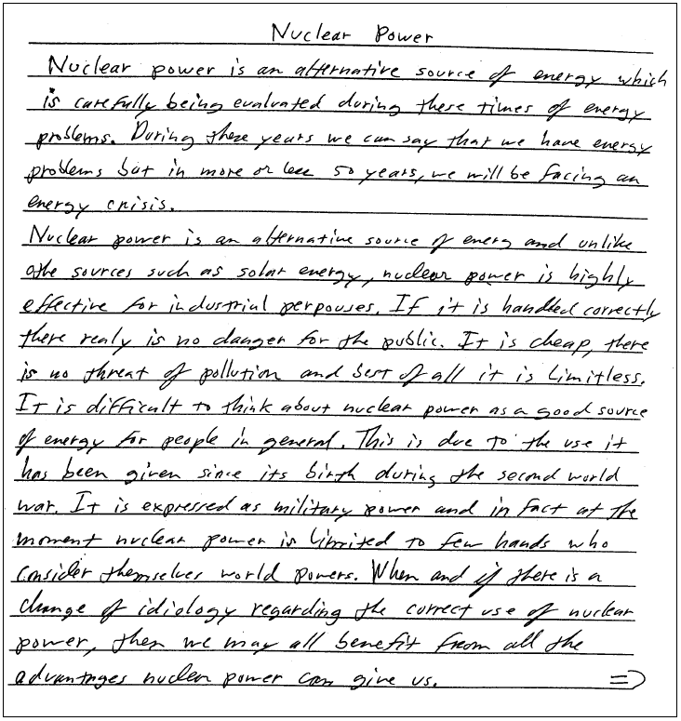

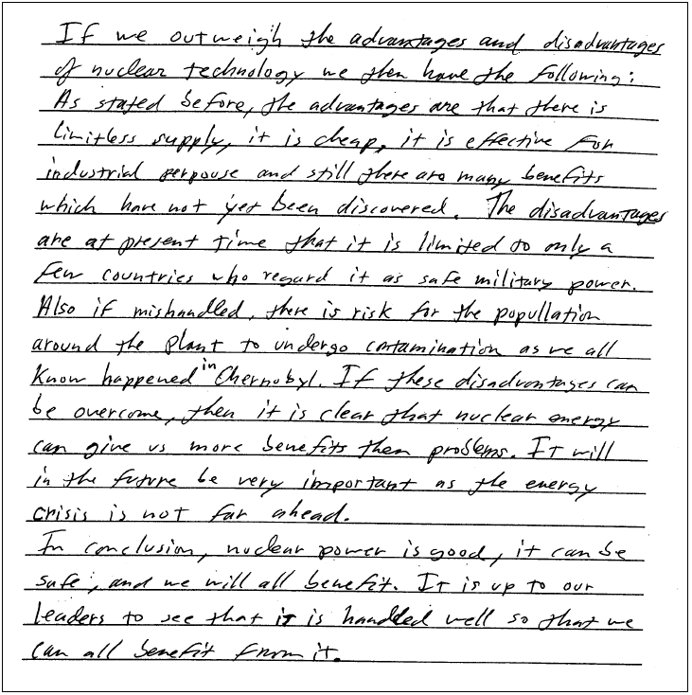

Examiner comment

Band 7
The answer is well-written and contains some good arguments. It does tend to repeat these arguments but the writer’s point of view remains clear throughout. The message is easy to follow and ideas are arranged well with good use of cohesive devices. There are minor problems with coherence and at times the expression is clumsy and imprecise. There is a wide range of structures that are well handled with only small problems in the use of vocabulary, mainly in the areas of spelling and word choice.

